Dashboard - Site Widget

Site - Total Capacity
Showcase the total capacity in the number of the selected zones. If multiple dates are selected calculate the total capacity for each day and showcase the Total capacity utilization. (AND display line charts of each day's utilization).
100 people IN, 20 people OUT ===> Total Capacity is 80 People
Core details: Display the total capacity of zones in numbers.
Create separate widgets for people and vehicle.

Site - Capacity Utilization (%)
Calculate the Total capacity based on the logic mentioned above and calculate the % against the capacity of selected zones.
Core details: Display the percentage number of capacity utilization. Trigger an alert on the widget when any zone exceeds its capacity. If multiple dates are selected calculate utilization for each day and showcase the average capacity utilization. (Option 2 Display line charts of each day's utilization).
Create separate widgets for people and vehicle.
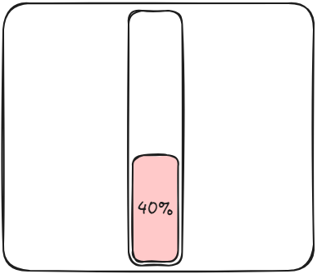

Site - Most vs Least Day for Capacity Utilization
From the selected date range calculate the capacity utilization of each day and find Most and least utilization.
Core details: Display most vs least capacity utilization with a date. Data is in numbers and dates.

Site - Zone wise details for Max Capacity, Utilization, % (Table)
Calculate the capacity utilization % of selected zones as per above mention logic.
Core details: Display zone name with the max utilization %, Use a table, or list to display data.

